July 22, 2019

Milpower Source, Inc.
7 Field Lane
Belmont, NH 03220
CAGE: 0B7R6
DUNS: 022715374

To Whom It May Concern,

The purpose of this letter is to communicate Milpower Source’s commitment to compliance with the Department of Commerce’s National Institute of Standards & Technology (NIST) Special Publication 800-171 (NIST SP800-171), Revision 1, specifying protection of Controlled Unclassified Information (CUI) on nonfederal systems and organizations.

As specified in the 2018 update to special publication 800-171, Milpower Source has implemented proper protections, standard practices, and processes within our organization to comply with the requirements for protection of CUI. An appropriate cybersecurity risk assessment was executed in 2018, with changes implemented by January 2019 to ensure compliance and proper risk reduction. Any questions pertaining to cybersecurity issues or compliance to the NIST special publication on CUI may be directed to the undersigned. Best

Regards,

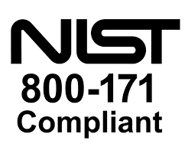

Brian Paul
General Manager
Milpower Source, Inc.

